2013 ANATOMY (B)
Sample Tournament

Station A:

Use the diagram in answering
Questions 1-5.

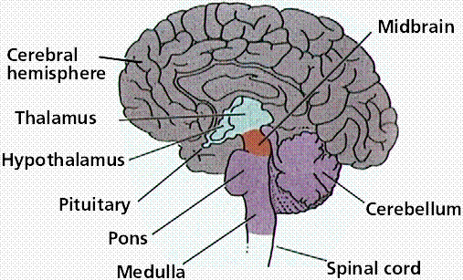

1. What is the function of the cerebellum?

2. What is the function of the cerebrum?

3. What is the function of the thalamus?

4. What is the function of the medulla?

5. Which parts make up the brainstem?

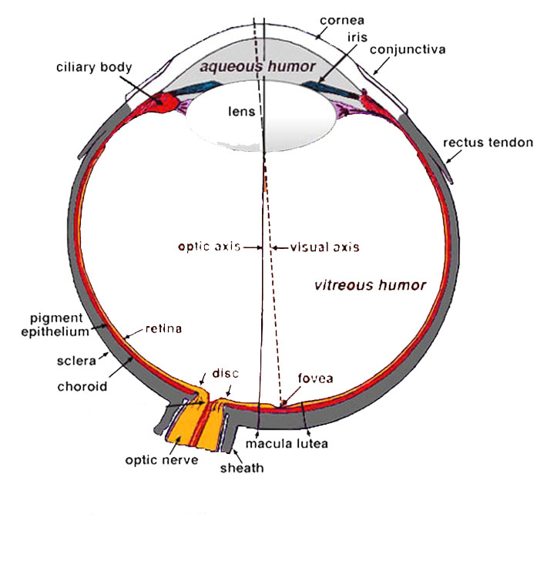

Station B:

6. Where are the rods and cones located?

7. Which layer has dark pigment to absorb extra light and keep the inside of the eye dark?

8. What part has the pigment for eye
color?

9. What substance keep the eye from collapsing?

10. What type of eye disorder is caused by the eyeball being too long? (nearsightedness or farsightedness)

Station C:

Examine the diagram and answer the following questions.
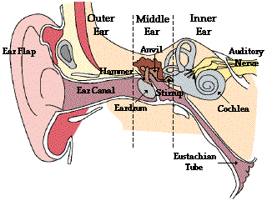

11. What is the role of the outer ear?

12. How do the ear drum and the three bones of the middle ear help with the transmission of sound?

13. What fills the cochlea of the middle ear to transmit sound?

14. What type of cells are the receptors for sound in the cochlea?

15. What is the role of the Eustachian tube?

Station D:

Examine the information provided and answer the questions.
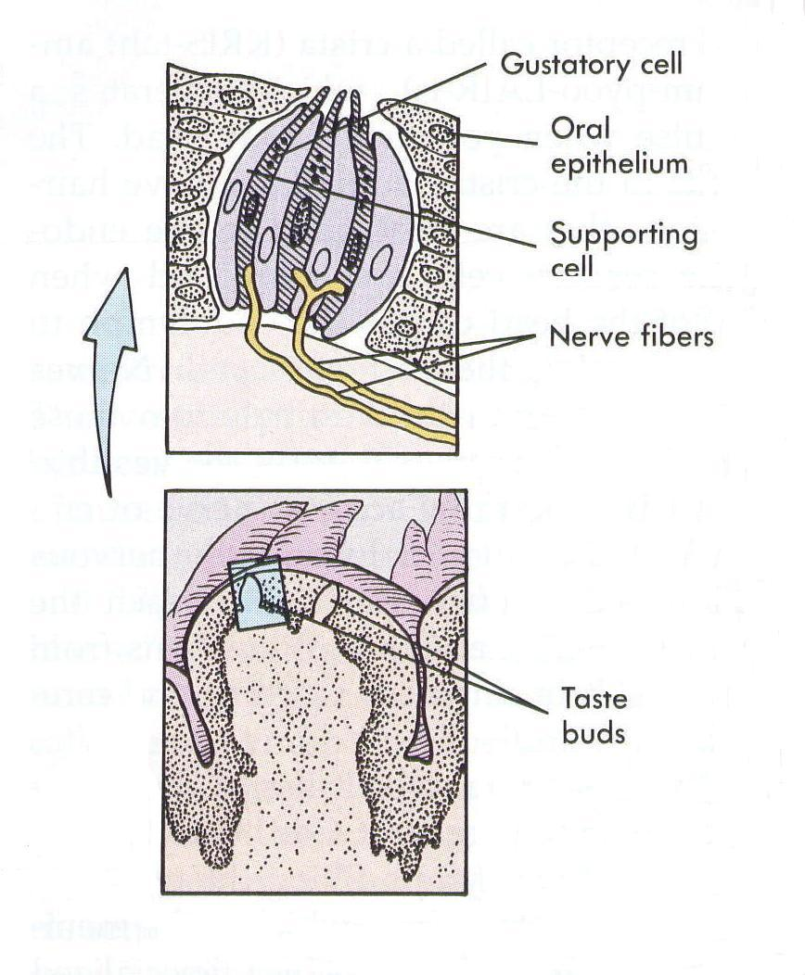
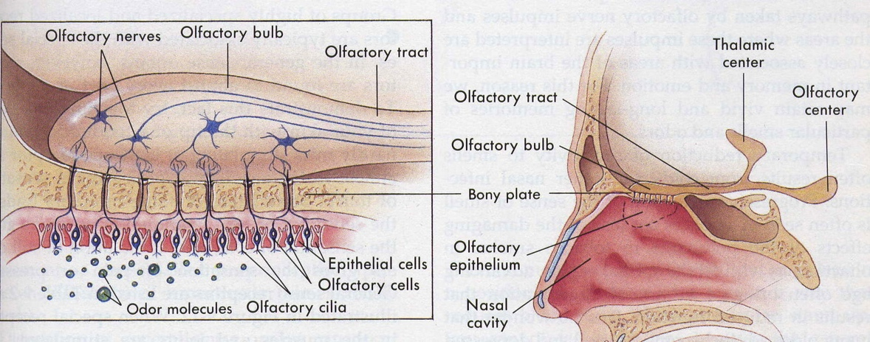

16. What type of receptors are taste and smell receptors? (what do they detect)

17. Where are most of your taste buds located?

18. Where are the smell receptors located and why does a cold affect the taste of food?

19. Why do hot food taste better than cold foods?
20. Why is smells so strongly attached to emotion and memory of events?

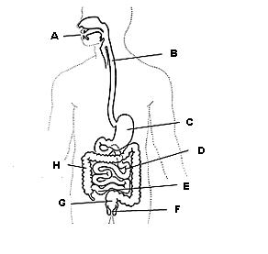
Station E:

21. Give the name and function of the part
indicated by the letter F.

22. Give the name and function of the part
indicated by the letter C.

23. Give the name and function of the part
indicated by the letter A.

24. Give the name and function of the part
indicated by the letter D

25. Give the name and function of the part
indicated by the letter H

Station F:

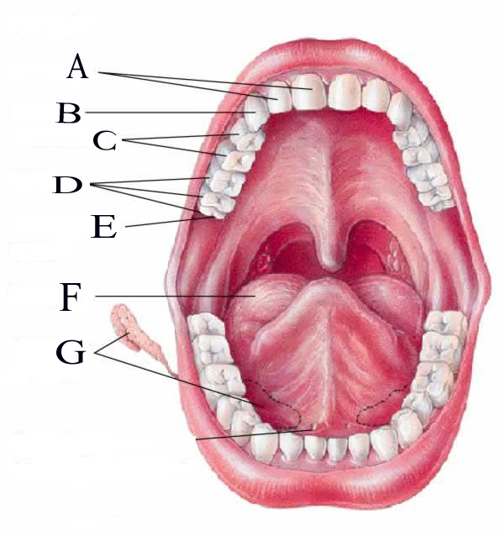

26. How many teeth does this adult have?

27. Many individuals have their “wisdom teeth”
pulled. Which letter represents these teeth?

28. What are the glands labeled “G” and what is
their function?

29. Give the letter from the diagram for the canine
teeth. How are they modified in carnivores?

30. Give the name and function of structure “F”

Station G:

Examine the Data on Digestion of a Meal and answer the following questions.

A person ate dinnerat 6 PM on Monday and the progress of the food through the
digestive system was recorded.
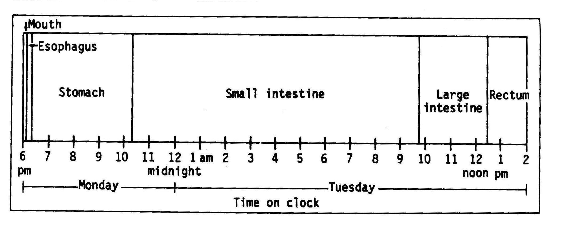

31. How many hours was the food from this meal in the digestive system?

32. How many hours was the food in the stomach? What percent of the total time
was spent in the stomach?

33. Where does most of the digestion of food take place? What percent of the total time
was spent in this part of the digestive system?

34. In what two parts of the digestive system does the food spend the least amount of time?
About how many minutes are spent in these two regions combined?

35. In what region of the digestive system is digestion aided by bacteria for
additional extraction and absorption of nutrients, salts, and water?
What percent of the total time is spent in this region?

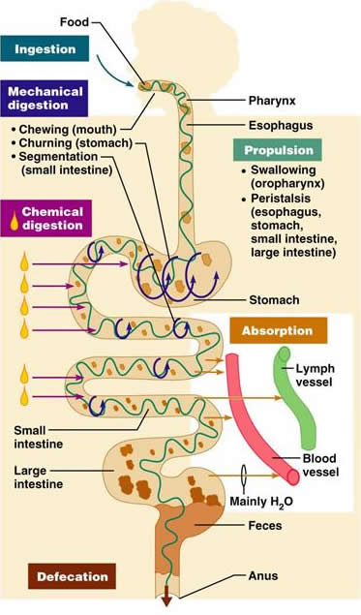
Station H:

36. What three areas of the alimentary canal are involved in mechanical digestion?

37. What process involving muscle contraction allows the food to be moved through the digestive system?

38. What two organs do most of the chemical digestion of food?

39. Where does most of the absorption of nutrients take place?

40. Where does most of the water absorption of water and formation of feces take place?

Station I:

Explain the effects of the following drugs on the nervous system .

41. alcohol

42. caffeine

43 nicotine .

Describe the two types of fiber and explain their role in digestion.

44.

45.

Station J:

For each of the following conditions, explain the cause and symptoms.

46. Asthma

47. Pneumonia

48. Lactose intolerance

49. Diarrhea

50. Stomach ulcer

Practice Exercise:

Develop Stations which collect data, interpret actual experimental data, and/or address questions related to the function of the skeletal and muscular systems in health and disease. Formulate questions and answers related to these stations.

2013ANATOMY (B) - Sample Tournament – Answer Key
Station A
1. Muscle coordination, balance, muscle tone
2. Conscious activity
3. Brain’s switchboard
4. Vital reflexes as heart beat, respiration
5. Medulla, pons, and midbrain

Station B
6. Retina
7. Choroid
8. Iris
9. Vitreous humor
10. nearsightedness – Myopia

Station C:
11. the outer collects sound and funnel it toward the eardrum
12. the eardrum and ossicles vibrate to transmit the sound to the inner ear
13. the cochlea is filled with fluid with vibrates like waves
14. the receptor are special hair cells with are stimulated by the fluid waves and initiate an impulse
15. the Eustachian tube helps to equalize pressure on both sides of the eardrum

Station D:
16. Taste and Smell are chemical receptors
17. Most taste buds are on the tongue but some line the surface of the mouth
18. Smell receptors are on the top of the nose and mucus from a cold can cover them
so odor chemicals cannot get to them thus reducing ability to smell and smell is perceived as
part of taste
19. Hot food emit more odors than cold food and smell is perceived as part of taste
20. The brain region for smell is close to the emotion center (limbic system)

Station E:
21. Anus – expels undigested waste (muscles control removal & prevent leakage)
22. Stomach – high pH – protein digestion begins – food is reduced to liquid
23. Mouth – chewing food into a ball – start starch digestion
24. Small intestine – most of enzymatic digestion and absorption of nutrients
25. Large intestine – bacterial help to finish digestion and reabsorb water.

Station F:
26. 32 teeth
27. E (wisdom teeth)
28. Salivary gland produces saliva as lubricant, antiseptic, and begins starch digestion
29. B – canine are long and pointed in carnivores
30. tongue – manipulates food into ball for swallowing and helps with speech

Station G:
31. 20 hours
32. about 4 hours
33. small intestine – about 58% (50 – 60 %)
34. Mouth and esophagus – about 15 min or ¼ hour
35. Large Intestine – about 14 % ( 10-15%)

Station H:
36. mouth, stomach, and small intestine
37. peristalsis
38. stomach and small intestine
39. small intestine
40. large intestine

Station I:
41. Alcohol - central nervous system depressant – cell membranes are highly permeable to alcohol so once in the bloodstream it can diffuse into almost all body tissues. It is absorbed in the stomach so it gets into the blood stream quickly and slows down function of the nervous system
42. Caffeine -- acts as a central nervous system stimulant - caffeine suppresses melatonin for up to 10 hours and also promotes adrenalin. Melatonin is strongly associated with quality sleep, while adrenalin is the neurotransmitter associated with alertness
43. Nicotine - - small doses of nicotine have a stimulating action on the central nervous system – it is
highly addictive nicotine's effects on the brain cause an increased release of neurotransmitters associated with pleasure. The brain quickly adjusts to repeated nicotine consumption by
decreasing the amount of neurotransmitters released. The effect of this increased tolerance is that the smoker must continue to use nicotine in order to avoid the feelings of discomfort associated with withdrawal from the drug. Irritability and anxiety often ensue during nicotine withdrawal

44.-45. Role of Fiber

There are two types – insoluble fiber and soluble fiber

Insoluble fiber is a type of fiber which cannot be dissolved in water

Insoluble fiber draws water to the intestine, increasing the bulk and softness of waste products

Soluble fiber which can be dissolved in water

Soluble fiber can be digested slowly and it slows the digestive process and keeps the stomach fuller longer leaving the body feeling full for a longer period of time

Digestion and absorption of carbohydrates are slower so that glucose (sugar) in food enters the bloodstream more slowly, which keeps blood sugar on a more even level
- The slow absorption of sugar gives the body an opportunity to regulate blood sugar levels
Station J:
46. Asthma - allergens trigger the release of histamine and other inflammatory chemicals that cause
intense bronchoconstriction
47. Pneumonia - lower respiratory infection that causes fluid build up in the lungs

48. Lactose Intolerance - the inability to digest and metabolize lactose, a sugar found in milk caused by a lack of the enzyme lactase in the digestive system

49. Diarrhea – loose, watery, and frequent stools or bowl movements – prolonged it can cause dehydration

50. Stomach l ulcers – open sores or lesions found in the stomach - most ulcers (90 percent of duodenal ulcers) develop as a result of infection with a bacterium called Helicobacter pylori (H. pylori).

